**Project Report**

On

**Recognition of Human Iris Patterns for Biometric Identification**

(A project report submitted in fulfillment of the requirements of Bachelor of Technology in Information Technology of the Maulana Abul Kalam Azad University of Technology,

West Bengal)

Submitted by,

**AADARSH PANDEY (10200215001)**

**ABHISHEK GHOSH (10200215003)**

**AYAN CHOWDHURY (10200215011)**

**BISHAL MUKHERJEE (10200215014)**

Under the guidance of

### Dr. SATYENDRA NATH MANDAL

Assistant Professor

Dept. of Information Technology



### Kalyani Government Engineering College

(Affiliated to Maulana Abul Kalam Azad University of Technology) Kalyani – 741235, Nadia, West Bengal

2018-2019

### Phone: 25826680 (PBX)

**Fax: 25821309**



**Certificate of Approval**

This is to certify that AADARSH PANDEY, ABHISHEK GHOSH, AYAN CHOWDHURY and BISHAL MUKHERJEE have done final year project work entitled **Recognition of Human Iris Patterns for Biometric Identification** under my direct supervision and they have fulfilled all the requirements of relating to the Final Year Project. It is also certified that this project work being submitted, fulfills the norms of academic standard for B. Tech Degree in Information Technology of the Maulana Abul Kalam Azad University of Technology and it has not been submitted for any degree whatsoever by them or anyone else previously.

------------------------------------ ----------------------------------

### Head Supervisor/Guide

Department of Information Technology Department of Information Technology Kalyani Government Engineering College Kalyani Government Engineering College

----------------------------------------- ------------------------------------

### Project Coordinator Examiner

Department of Information Technology Kalyani Government Engineering College

# ACKNOWLEDGEMENTS

We prepared this project report after the partial completion of our project **“Recognition of Human Iris Patterns for Biometric Identification”**.

We are very grateful to **Assistant Prof. Dr. Satyendra Nath Mondal**, our project guide (Assistant Prof. of the Department of Information Technology, Kalyani Govt. Engineering College) who helped us to undertake the project by providing continuous support and assistance.

We would like to express our heartiest gratitude to **Assistant Prof. Md. Iqbal Quraishi** (B. Tech Project Coordinator of the Department of Information Technology, Kalyani Govt. Engineering College) and **H. O. D of the Department of Information Technology**, Kalyani Govt. Engineering College, who allowed us to undertake this project.

Our special thanks to all the faculty member of Kalyani Govt. Engineering College, who rendered their help during the period of our study and project work.

Place: Kalyani Date:03/12/18

----------------------------------- -----------------------------------

AYAN CHOWDHURY ABHISHEK GHOSH

B. Tech (IT) B. Tech (IT)

Roll No: 10200215011 Roll No: 10200215003

----------------------------------- -----------------------------------

AADARSH PANDEY BISHAL MUKHERJEE

B. Tech (IT) B. Tech (IT)

Roll No: 10200215001 Roll No: 10200215014

# Abstract

A biometric system provides automatic identification of an individual based on a unique feature or characteristic possessed by the individual. Iris recognition is regarded as the most reliable and accurate biometric identification system available. Most commercial iris recognition systems use patented algorithms developed by Daugman, and these algorithms are able to produce perfect recognition rates. However, published results have usually been produced under favourable conditions, and there have been no independent trials of the technology.

The work presented in this thesis involved developing an ‘open-source’ iris recognition system in order to verify both the uniqueness of the human iris and also its performance as a biometric. For determining the recognition performance of the system two databases of digitised greyscale eye images were used.

The iris recognition system consists of an automatic segmentation system that is based on the Hough transform, and is able to localise the circular iris and pupil region, occluding eyelids and eyelashes, and reflections. The extracted iris region was then normalised into a rectangular block with constant dimensions to account for imaging inconsistencies. Finally, the phase data from 1D Log-Gabor filters was extracted and quantised to four levels to encode the unique pattern of the iris into a bit-wise biometric template.

# The Hamming distance was employed for classification of iris templates, and two templates were found to match if a test of statistical independence was failed. The system performed with perfect recognition on a set of 75 eye images; however, tests on another set of 624 images resulted in false accept and false reject rates of 0.005% and 0.238% respectively. Therefore, iris recognition is shown to be a reliable and accurate biometric technology.

# CONTENTS

|  |  |
| --- | --- |
| **CHAPTER 1: INTRODUCTION** | 1 - 11 |
| 1.1 Objective | 1 |
| 1.2 Motivation | 1 |
| 1.3 Background | 1 - 2 |
| 1.4 Algorithmic Overview | 3 - 5 |
| 1.5 Summary of Present Work | 6 - 10 |
| 1.6 Organization of the Report | 10 |
| 1.7 Hardware/Software used | 11 |
|  |  |

**CHAPTER 2: SEGMENTATION**  6-13

|  |  |
| --- | --- |
| 2.1 Overview 6  2.2 Literature Overview 6-9  2.2.1 Dimension Reduction 6  2.2.2 Top-Hat Transform 6  2.2.3 Median filter 7  2.2.4 Gaussin smoothing filter 7  2.2.5 Canny edge detection 8  2.2.6 Circular Hough Transfrom 9  2.3 Implementation 10-12  2.4 Results 13  **CHAPTER 3: NORMALIZATION** 14-17  3.1 Overview 14  3.2 Literature Overview 14-15  3.2.1 Daugman’s Rubber Sheet Model 14  3.3 Implementation 16  3.4 Results 17 | 12 |
|  |  |

**CHAPTER 4: FEATURE ENCODING AND MATCHING**  18-20

4.1 Overview 18

4.2 Literature Overview 18-20

4.2.1 Wavelet Encoding 18

4.2.2 Gabor Filter 18

4.2.3 Feature Encoding 20

4.2.4 Matching 20

**CHAPTER 5: CONCLUSION** 21

5.1 Coclusion 21

5.2 Future Work 21

**BIBLIOGRAPHY**  22

**INTRODUCTION**

**1.1 OBJECTIVE**

The objective is to implement an iris recognition system for identifying Human (*Homo sapiens*) uniquely. The development tool used is OpenCV in Python and other depenent python libraries, and emphasis will not only be on the software for performing Identification through recognition but also the identification of Biological syndroms of any human. A rapid application development (RAD) approach will be employed in order to produce results quickly. To perform the experimentation, a dataset containing eye images of more than 100 human eye image taken from different angle, from the CASIA database is used.

**1.2 MOTIVATION**

The chief motivation behind this project was the objective of the project and the desire to achieve it. We have been trying and have been to some extent successful in this project and aim to get better and better with time. We have been greatly motivated by our guide and hope to get more and more from him. Another source of motivation can be -Google who are are trying to detect medical condition based on iris pattern and where they have already published a paper on it. We have a plan to study a lot from these papers be motivated.We are in constant contact with our guide for help so that we could extend the ideas and implement our own ideas for successful implementation.

**1.3 BACKGROUND**

Human recognition system has been playing a dominant role in modern society. Any person can be identified by their biometric traits like fingerprint, iris, retina, ear etc. They can be also identified by their behavioral status like hand-writing, fingerprint etc. But Iris pattern is considered one of the best if not the best way to identify any human being. So the background of the project is the implementation of successful opencv image processing with python to segment, normalize and extract feature from the image to enable us to get a data value from the Iris image.

**Iris Biometrics**

* Iris is externally Visible, coloured ring around the pupil
* Iris is stable throughout life
* Unique patterns of iris are not related to genetic factors
* Both right and left eye have non-matching iris patterns
* The flowery pattern is unique for each individual
* Randomness

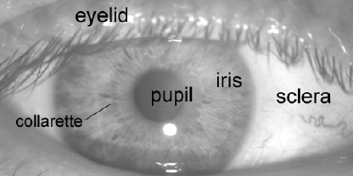

**Biometric Technology and Iris**

A biometric system provides automatic recognition of an individual based on some sort of unique feature or characteristic possessed by the individual. Biometric systems have been developed based on fingerprints, facial features, voice, hand geometry, handwriting, the retina, and the one presented in this project, the iris. The iris is an externally visible, yet protected organ whose unique epigenetic pattern remains stable throughout adult life. These characteristics make it very attractive for use as a biometric for identifying individuals. The purpose of ‘Iris Recognition’, a biometrical based technology for individual identification and verification, is to recognize a human from his iris prints. In fact, iris patterns are characterized by high level of stability and distinctiveness. Each individual has a unique iris. The difference even exists between identical twins and between the left and right eye of the same human. The probability of finding two human with identical iris patterns is considered to be approximately 1 in infinite. Not even one-egged twins or a future clone of a human will have the same iris patterns. The iris is considered to be an internal organ because it is so well protected by the eyelid and the cornea from environmental damage. Iris recognition is the most precise and fastest of the biometric authentication method.

## ALGORITHMIC OVERVIEW

* + 1. Theo Pavlidis (1982) [2] devised the algorithm for contour tracing of any particular image. This algorithm is known as Theo Pavlidis algorithm. Without loss of generality, we trace the contour in a clockwise direction in order to be consistent with the other contour tracing algorithms like square tracing algorithm, moore–neighbour. On the other hand, Pavlidis chooses to do so in a counterclockwise direction. This shouldn't make any difference towards the performance of the algorithm. The only effect this will have is on the relative direction of movements we will be making while tracing the contour. Given a digital pattern i.e. a group of black pixels, on a background of white pixels i.e. a grid; locate a black pixel and declare it as your "start" pixel. Locating a "start" pixel can be done in a number of ways; one of which is done by starting at the bottom left corner of the grid, scanning each column of pixels from the bottom going upwards -starting from the leftmost column and proceeding to the right- until a black pixel is encountered. This way the start pixel can be determined.
    2. Active contour model, also called snakes [3], is a framework in computer vision for delineating an object outline from a possibly noisy 2D image. The snakes model is popular in computer vision, and snakes are greatly used in applications like object tracking, shape recognition, segmentation, edge detection and stereo matching. A snake is an energy minimizing, deformable spline influenced by constraint and image forces that pull it towards object contours and internal forces that resist deformation. Snakes may be understood as a special case of the general technique of matching a deformable model to an image by means of energy minimization in two dimensions, the active shape model represents a discrete version of this approach, taking advantage of the point distribution model to restrict the shape range to an explicit domain learnt from a training set. Snakes do not solve the entire problem of finding contours in images, since the method requires knowledge of the desired contour shape beforehand. Rather, they depend on other mechanisms such as interaction with a user, interaction with some higher level image understanding process, or information from image data adjacent in time or space.
    3. Dennis Gabor in 1946 first proposed the canonical coherent states of the Gabor filters [4] are different versions of a Gaussian-shaped window shifted in time/space and frequency variables [5] [6]. Gabor's work synthesizes the studies of Nyquist in Communication Theory in 1924[7] and Heisenberg in Quantum Mechanics in 1927, by which he proposed the Gaussian shape as an optimal envelope for time-frequency representation turning the uncertainly principle from inequality into equality. There are several features of Gabor
    4. wavelets like energy preservation in transform domain, time/space and frequency shift- invariance. localization: monomodal and isotropic, Regularity: smooth and infinitely drivable. Along with these in the field of image processing another two special characteristics are:

Directionality: filters can be rotated to discriminate spectral features in multiples directions (orthogonal wavelets have well-known difficulties to discriminate more than three orientations).

Complex modulation (odd/even phases): effective for analyzing different phased features like abrupt ridges or edges.

Gabor filters are widely usage in multiple fields such as: texture analysis/synthesis [8]. contour extraction [9] [10], segmentation [11], object recognition [12], image analysis and

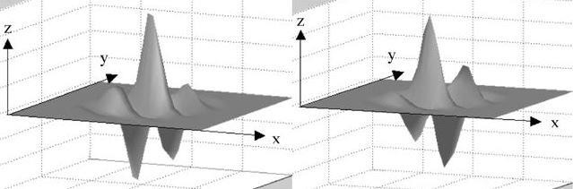compression [13], movement estimation [14].

Real component or even symmetric filter Imaginary component or odd symmetric filter (cosine) (sine)

**Fig 1.1: A quadrature pair of 2D Gabor filters**

* + 1. The hamming distance is named after Richard hamming, who introduced the concept in his paper on Hamming codes in 1950 [1]. Hamming distance is used in several disciplines like information theory, coding theory, and cryptography. In information theory hamming distance between two strings of equal length is the number of positions at which corresponding symbols are different. It is used in telecommunication to count the number of flipped bits in a fixed-length binary word as an estimate of error, and therefore is sometimes called the signal distance. For q-ary strings over an alphabet of size q ≥ 2 the Hamming distance is applied in case of the q-ary symmetric channel. It computes the Hamming distance between two strings (or other iterable objects) of equal length by creating a sequence of Boolean values indicating mismatches and matches between corresponding positions in the two inputs and then summing the sequence with False and True values being interpreted as zero and one.
    2. 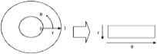The homogenous rubber sheet model devised by Daugman [15] remaps each point within the iris region to a pair of polar coordinates (r, θ) where r is on the interval [0,1] and θ is angle [0,2π].

**Fig 1.2: Schematic diagram of Daugman Rubber Sheet Model**

The remapping of the iris region from (x, y) Cartesian coordinates to the normalized non- concentric polar representation is modelled as



with



where I (x, y) is the iris region image, (x, y) are the original Cartesian coordinates, (r, θ) are the corresponding normalized polar coordinates, and xp, yp and xl, yl are the coordinates of the pupil and iris boundaries along the θ direction. The rubber sheet model takes into account pupil dilation and size inconsistencies in order to produce a normalized representation with constant dimensions. In this way the iris region is modelled as a flexible rubber sheet anchored at the iris boundary with the pupil center as the reference point. Even though the homogenous rubber sheet model accounts for pupil dilation, imaging distance and non-concentric pupil displacement, it does not compensate for rotational inconsistencies. In the Daugman system, rotation is accounted for during matching by shifting the iris templates in the θ direction until two iris templates are aligned.

HARDWARE/SOFTWARE USED

* 1. Hardware Requirements:
     + 1. Intel Core i5
       2. 2.4. GHZ processor
       3. 4 GB RAM
       4. 4 GB of free hard disk space
  2. Keyboard, mouse

2. Software Requirements:

* + - 1. Operating system – windows 8/8.1/10
      2. Python (OpenCV)
      3. Jupyter Notebook/ Anaconda

**Segmentation**

## **2.2 Overview**

The first stage of iris recognition is to isolate the actual iris region in a digital eye image. The iris region, shown in Figure 1.1, can be approximated by two circles, one for the iris/sclera boundary and another, interior to the first, for the iris/pupil boundary. The eyelids and eyelashes normally occlude the upper and lower parts of the iris region. Also, specular reflections can occur within the iris region corrupting the iris pattern. A technique is required to isolate and exclude these artefacts as well as locating the circular iris region.

The success of segmentation depends on the imaging quality of eye images. Images in the CASIA iris database [13] do not contain specular reflections due to the use of near infra-red light for illumination. However, the images in the LEI database [14] contain these specular reflections, which are caused by imaging under natural light. Also, persons with darkly pigmented irises will present very low contrast between the pupil and iris region if imaged under natural light, making segmentation more difficult. The segmentation stage is critical to the success of an iris recognition system, since data that is falsely represented as iris pattern data will corrupt the biometric templates generated, resulting in poor recognition rates.

**2.2 Literature Review**

### 2.2.1 Dimension Reduction

The **lightness** method averages the most prominent and least prominent colors: (max(R, G, B) + min(R, G, B)) / 2. The **average** method simply averages the values: (R + G + B) / 3. The **luminosity** method is a more sophisticated version of the average method. It also averages the values, but it forms a weighted average to account for human perception. We’re more sensitive to green than other colors, so green is weighted most heavily. The formula for luminosity is 0.21 R + 0.72 G + 0.07 B.

**2.2.2 Top-Hat Transform**

In [mathematical morphology](https://en.wikipedia.org/wiki/Mathematical_morphology) and [digital image processing](https://en.wikipedia.org/wiki/Digital_image_processing), top-hat transform is an operation that extracts small elements and details from given [images](https://en.wikipedia.org/wiki/Image). There exist two types of top-hat transform: The *white top-hat transform* is defined as the difference between the input image and its [opening](https://en.wikipedia.org/wiki/Opening_(morphology)) by some [structuring element](https://en.wikipedia.org/wiki/Structuring_element); The *black top-hat transform* is defined dually as the difference between the [closing](https://en.wikipedia.org/wiki/Closing_(morphology)) and the input image. Top-hat transforms are used for various image processing tasks, such as [feature extraction](https://en.wikipedia.org/wiki/Feature_extraction), background equalization, [image enhancement](https://en.wikipedia.org/wiki/Image_enhancement), and others.

The black top-hat returns an image, containing the "objects" or "elements" that:

* Are "smaller" than the structuring element, and
* are **darker** than their surroundings.

The size, or width, of the elements that are extracted by the top-hat transforms can be controlled by the choice of the structuring element {\displaystyle b}. The bigger the latter, the larger the elements extracted.

Both top-hat transforms are images that contain only non-negative values at all pixels. One of its most important uses in image segmentation is to adjust nonuniform lighting conditions on an image and provide a better threshold value for separating objects.

Let f : E <->R be a grayscale image , mapping points from a Euclidian space or discrete grid E(such as R2 or Z2) into a real line. Let b(x) be a grayscale structuring element.

The black Top hat transform of f ( Sometimes called bottom hat transform ) is given by

Tb(f) =f - f \* b

Where \* is the closing operation.

**2.2.3 Median Filter**

The **Median Filter** is a non-linear [digital filtering](https://en.wikipedia.org/wiki/Digital_filter) technique, often used to remove [noise](https://en.wikipedia.org/wiki/Signal_noise) from an image or signal. Such [noise reduction](https://en.wikipedia.org/wiki/Noise_reduction) is a typical pre-processing step to improve the results of later processing (for example, [edge detection](https://en.wikipedia.org/wiki/Edge_detection) on an image). Median filtering is very widely used in digital [image processing](https://en.wikipedia.org/wiki/Image_processing) because, under certain conditions, it preserves edges while removing noise (but see discussion below), also having applications in [signal processing](https://en.wikipedia.org/wiki/Signal_processing).

The main idea of the median filter is to run through the signal entry by entry, replacing each entry with the [median](https://en.wikipedia.org/wiki/Median) of neighboring entries. The pattern of neighbors is called the "window", which slides, entry by entry, over the entire signal. For 1D signals, the most obvious window is just the first few preceding and following entries, whereas for 2D (or higher-dimensional) signals such as images, more complex window patterns are possible (such as "box" or "cross" patterns). Note that if the window has an odd number of entries, then the [median](https://en.wikipedia.org/wiki/Median) is simple to define: it is just the middle value after all the entries in the window are sorted numerically. For an even number of entries, there is more than one possible median

**2.2.4 Gaussian Smoothing filter**

In [image processing](https://en.wikipedia.org/wiki/Image_processing), a **Gaussian blur** (also known as **Gaussian smoothing**) is the result of blurring an image by a [Gaussian function](https://en.wikipedia.org/wiki/Gaussian_function) (named after mathematician and scientist [Carl Friedrich Gauss](https://en.wikipedia.org/wiki/Carl_Friedrich_Gauss)). It is a widely used effect in graphics software, typically to reduce [image noise](https://en.wikipedia.org/wiki/Image_noise) and reduce detail. The visual effect of this blurring technique is a smooth blur resembling that of viewing the [image](https://en.wikipedia.org/wiki/Image) through a translucent screen, distinctly different from the [bokeh](https://en.wikipedia.org/wiki/Bokeh) effect produced by an out-of-focus lens or the shadow of an object under usual illumination. Gaussian smoothing is also used as a pre-processing stage in [computer vision](https://en.wikipedia.org/wiki/Computer_vision) algorithms in order to enhance image structures at different scales—see [scale space representation](https://en.wikipedia.org/wiki/Scale_space_representation) and [scale space implementation](https://en.wikipedia.org/wiki/Scale_space_implementation).

Mathematically, applying a Gaussian blur to an image is the same as [convolving](https://en.wikipedia.org/wiki/Convolution) the image with a [Gaussian function](https://en.wikipedia.org/wiki/Gaussian_function). This is also known as a two-dimensional [Weierstrass transform](https://en.wikipedia.org/wiki/Weierstrass_transform" \o "Weierstrass transform). By contrast, convolving by a circle (i.e., a circular [box blur](https://en.wikipedia.org/wiki/Box_blur)) would more accurately reproduce the [bokeh](https://en.wikipedia.org/wiki/Bokeh) effect. Since the [Fourier transform](https://en.wikipedia.org/wiki/Fourier_transform) of a Gaussian is another Gaussian, applying a Gaussian blur has the effect of reducing the image's high-frequency components; a Gaussian blur is thus a [low pass filter](https://en.wikipedia.org/wiki/Low_pass_filter).

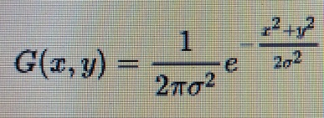

where *x* is the distance from the origin in the horizontal axis, *y* is the distance from the origin in the vertical axis, and *σ* is the [standard deviation](https://en.wikipedia.org/wiki/Standard_deviation) of the Gaussian distribution. When applied in two dimensions, this formula produces a surface whose [contours](https://en.wiktionary.org/wiki/contour) are [concentric circles](https://en.wikipedia.org/wiki/Concentric_circles) with a Gaussian distribution from the center point. Values from this distribution are used to build a [convolution](https://en.wikipedia.org/wiki/Convolution) matrix which is applied to the original image. This convolution process is illustrated visually in the figure on the right. Each pixel's new value is set to a [weighted average](https://en.wikipedia.org/wiki/Weighted_average) of that pixel's neighborhood. The original pixel's value receives the heaviest weight (having the highest Gaussian value) and neighboring pixels receive smaller weights as their distance to the original pixel increases. This results in a blur that preserves boundaries and edges better than other, more uniform blurring filters

**2.2.5 Canny Edge Detection**

Canny Edge Detection is a popular edge detection algorithm. It was developed by John F. Canny in 1986. It is a multi-stage algorithm and we will go through each stages. Since edge detection is susceptible to noise in the image, first step is to remove the noise in the image with a 5x5 Gaussian filter.

Smoothened image is then filtered with a Sobel kernel in both horizontal and vertical direction to get first derivative in horizontal direction (G_x) and vertical direction (G_y). From these two images, we can find edge gradient and direction for each pixel as follows:

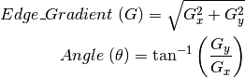

Gradient direction is always perpendicular to edges. It is rounded to one of four angles representing vertical, horizontal and two diagonal directions.

After getting gradient magnitude and direction, a full scan of image is done to remove any unwanted pixels which may not constitute the edge. For this, at every pixel, pixel is checked if it is a local maximum in its neighborhood in the direction of gradient. Check the image below:

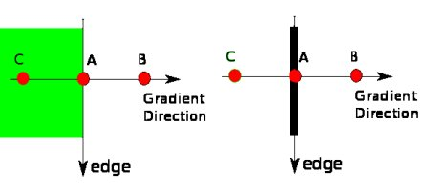

Point A is on the edge ( in vertical direction). Gradient direction is normal to the edge. Point B and C are in gradient directions. So point A is checked with point B and C to see if it forms a local maximum. If so, it is considered for next stage, otherwise, it is suppressed ( put to zero). In short, the result you get is a binary image with “thin edges”.

**2.2.6 Circular Hough Transform**

The circle Hough Transform (CHT) is a basic technique used in Digital Image Processing, for detecting circular objects in a digital image.

The circle Hough Transform (CHT) is a [feature extraction](https://en.wikipedia.org/wiki/Feature_extraction) technique for detecting circles. It is a specialization of [Hough Transform](https://en.wikipedia.org/wiki/Hough_Transform). The purpose of the technique is to find circles in imperfect image inputs. The circle candidates are produced by “voting” in the Hough parameter space and then select the local maxima in a so-called accumulator matrix.

In a two-dimensional space, a circle can be described by:

(x-a)2+(y-b)2 = r2{\displaystyle \left(x-a\right)^{2}+\left(y-b\right)^{2}=r^{2}\ \ \ \ \ (1)}

where (a,b) is the center of the circle, and r is the radius. If a 2D point (x,y) is fixed, then the parameters can be found according to (1). The parameter space would be three dimensional, (a, b, r). And all the parameters that satisfy (x, y) would lie on the surface of an inverted right-angled cone whose apex is at (x, y, 0). In the 3D space, the circle parameters can be identified by the intersection of many conic surfaces that are defined by points on the 2D circle. This process can be divided into two stages. The first stage is fixing radius then find the optimal center of circles in a 2D parameter space. The second stage is to find the optimal radius in a one dimensional parameter space.

If the radius is fixed, then the parameter space would be reduced to 2D (the position of the circle center). For each point (x, y) on the original circle, it can define a circle centered at (x, y) with radius R according to (1). The intersection point of all such circles in the parameter space would be corresponding to the center point of the original circle. Consider 4 points on a circle in the original image (left). The circle Hough transform is shown in the right. Note that the radius is assumed to be known. For each (x,y) of the four points (white points) in the original image, it can define a circle in the Hough parameter space centered at (x, y) with radius r. An accumulator matrix is used for tracking the intersection point. In the parameter space, the voting number of points through which the circle passing would be increased by one. Then the local maxima point (the red point in the center in the right figure) can be found. The position (a, b) of the maxima would be the center of the original circle.

## **Implementation**

2.3.1 Phase 1

the RGB input image is converted into grayscale for further processing, and morphological operation is applied through bottom-hat filtering with symmetrical structuring element disk of size 5 for contrast enhancement. Finally, two images of the gray image and resultant image by bottom-hat filtering are added to obtain an enhanced image

**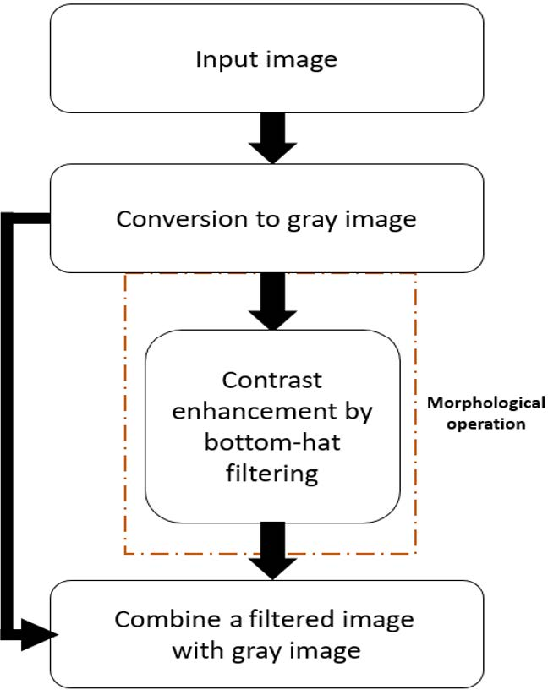**

Overall pre-processing procedure of Phase 1

**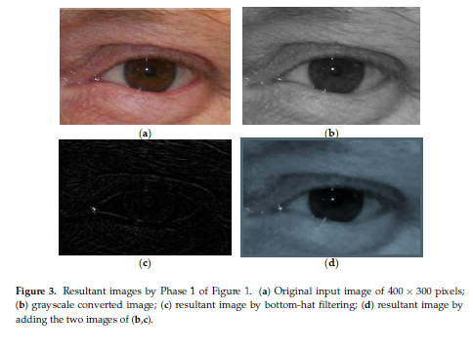**

2.3.2 Phase 2

The overall process of Phase 2 is presented by the flowchart in Figure 4. In Phase 2, the filtered image from Phase 1 is redefined as an image of 280 \_ 220 pixels to reduce the effect of eyebrowsin detecting the iris boundary. Then, a 17 \_ 17 median filter is applied to smooth the image from salt and pepper noises and reduce the skin tone and texture illumination. 13 \_ 13 symmetrical Gaussian smoothing filter with \_ of 2 is applied to the filtered image to increase pixel uniformity as shown in Figure 5d. Then, Canny edge detector with same \_ value is used to detect the edges of the iris boundary as shown in Figure 5e. However, the edges are not very clear, and gamma adjustment with *g* = 1.90 is applied to enhance the contrast of the image . With the gamma-enhanced image, the binarized edge image is obtained with eight neighbor connectivity . In this edge image, there are more circular edges along the iris boundary edges, and circular HT can find all possible circles in the image. However, the incorrect circle-type edges can be removed by filtering the edges whose radius is out of the range of the minimum and maximum human iris radius. Then, the most-connected edges are selected as iris edges, and the rough iris boundary is detected . Considering the possibility of detection error of the iris boundary, ROI is defined slightly larger than the detected boundary as. For fair comparisons, all the optimal parameters for the operation in ROI detection including

median filter, Gaussian smoothing filter, Canny edge detector, gamma adjustment, and binarization, etc., were empirically selected only by training data without testing data.

**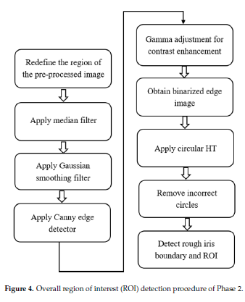**

**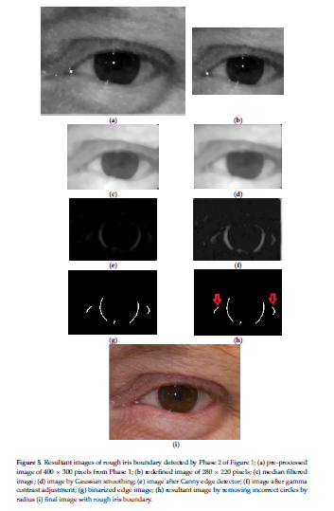**

**Results(Localization and Segmentation)**

**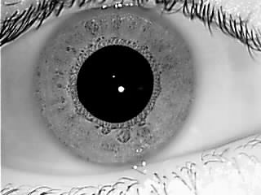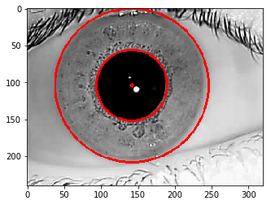**

**🡺**

**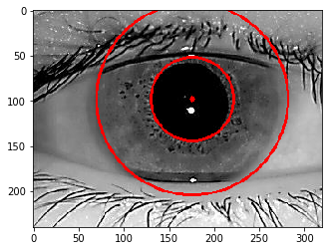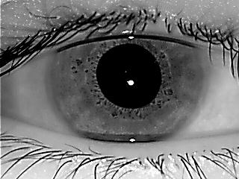**

**🡺**

**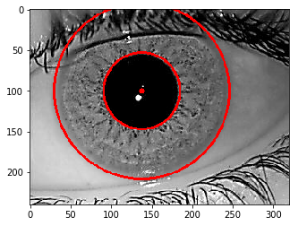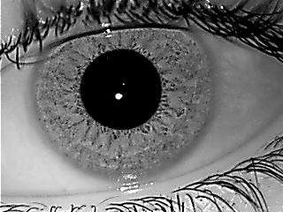**

**🡺**

**Normalization**

## **3.1 Overview**

Once the iris region is successfully segmented from an eye image, the next stage is to transform the iris region so that it has fixed dimensions in order to allow comparisons. The dimensional inconsistencies between eye images are mainly due to the stretching of the iris caused by pupil dilation from varying levels of illumination. Other sources of inconsistency include, varying imaging distance, rotation of the camera, head tilt, and rotation of the eye within the eye socket. The normalization process will produce iris regions, which have the same constant dimensions, so that two photographs of the same iris under different conditions will have characteristic features at the same spatial location.

Another point of note is that the pupil region is not always concentric within the iris region, and is usually slightly nasal [2]. This must be taken into account if trying to normalize the ‘doughnut’ shaped iris region to have constant radius.

## **3.2**Literature Review

**3.2.1 Daugman’s Rubber Sheet Model**

The homogenous rubber sheet model devised by Daugman [1] remaps each point within the iris region to a pair of polar coordinates (*r,θ*) where *r* is on the interval [0,1] and *θ* is angle [0,2π].

**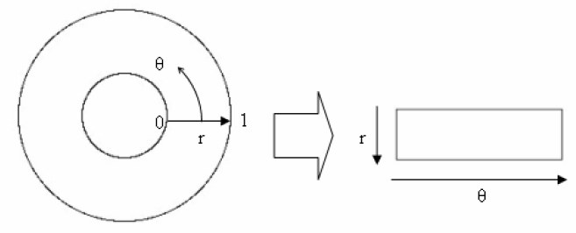**

**Figure 3.1- Daugman’s Rubber sheet model**

The remapping of the iris region from *(x,y)* Cartesian coordinates to the normalised non-concentric polar representation is modelled as

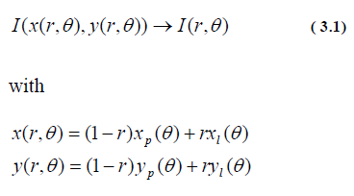

where *I(x,y)* is the iris region image, *(x,y)* are the original Cartesian coordinates, *(r,θ)* are the corresponding normalised polar coordinates, and and are the coordinates of the pupil and iris boundaries along the *θ* direction. The rubber sheet model takes into account pupil dilation and size inconsistencies in order to produce a normalised representation with constant dimensions. In this way the iris region is modelled as a flexible rubber sheet anchored at the iris boundary with the pupil centre as the reference point.

Even though the homogenous rubber sheet model accounts for pupil dilation, imaging distance and non-concentric pupil displacement, it does not compensate for rotational inconsistencies. In the Daugman system, rotation is accounted for during matching by shifting the iris templates in the *θ* direction until two iris templates are aligned.

**3.3 Implementation**

For normalisation of iris regions a technique based on Daugman’s rubber sheet model was employed. The centre of the pupil was considered as the reference point, and radial vectors pass through the iris region, as shown in Figure 3.2. A number of data points are selected along each radial line and this is defined as the radial resolution. The number of radial lines going around the iris region is defined as the angular resolution. Since the pupil can be non-concentric to the iris, a remapping formula is needed to rescale points depending on the angle around the circle. This is given by

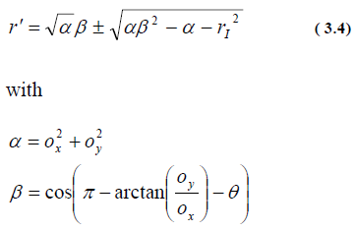

where displacement of the centre of the pupil relative to the centre of the iris is given by *ox* , *oy*, and *r’* is the distance between the edge of the pupil and edge of the iris at an angle, θ around the region, and *rI* is the radius of the iris. The remapping formula first gives the radius of the iris region ‘doughnut’ as a function of the angle *θ*.

A constant number of points are chosen along each radial line, so that a constant number of radial data points are taken, irrespective of how narrow or wide the radius is at a particular angle. The normalised pattern was created by backtracking to find the Cartesian coordinates of data points from the radial and angular position in the normalised pattern. From the ‘doughnut’ iris region, normalisation produces a 2D array with horizontal dimensions of angular resolution and vertical dimensions of radial resolution. Another 2D array was created for marking reflections, eyelashes, and eyelids detected in the segmentation stage. In order to prevent non-iris region data from corrupting the normalised representation, data points which occur along the pupil border or the iris border are discarded. As in Daugman’s rubber sheet model, removing rotational inconsistencies is performed at the matching stage and will be discussed in the next chapter.

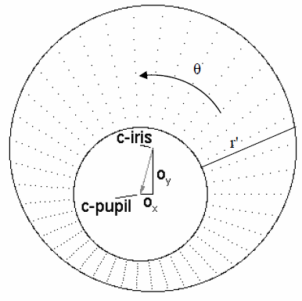

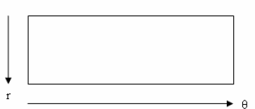

**Figure 3.2 - Outline of the normalisation process**

**3.4 Results**

The normalisation process proved to be successful and some results are shown in Figure 3.3. However, the normalisation process was not able to perfectly reconstruct the same pattern from images with varying amounts of pupil dilation, since deformation of the iris results in small changes of its surface patterns.

Normalisation of two eye images of the same iris is shown in Figure 3.3. The pupil is smaller in the bottom image, however the normalisation process is able to rescale the iris region so that it has constant dimension. In this example, the rectangular representation is constructed from 10,000 data points in each iris region. Note that rotational inconsistencies have not been accounted for by the normalisation process, and the two normalised patterns are slightly misaligned in the horizontal (angular) direction. Rotational inconsistencies will be accounted for in the matching stage.

**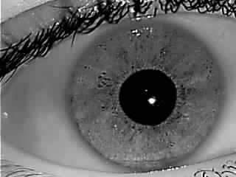Implementation and Results (Normalization)**

**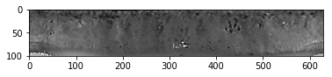**

**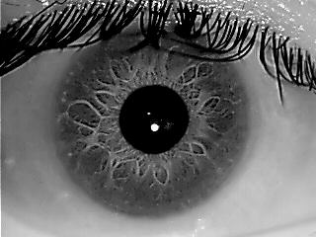**

**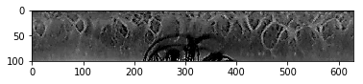**

**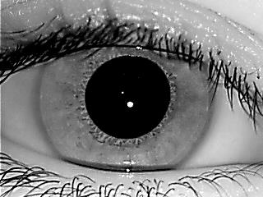**

**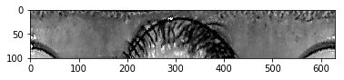**

**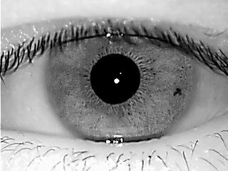**

**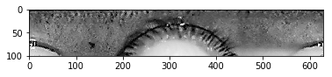**

**FEATURE ENCODING AND MATCHING**

**4.1 Overview**

In order to provide accurate recognition of individuals, the most discriminating information present in an iris pattern must be extracted. Only the significant features of the iris must be encoded so that comparisons between templates can be made. Most iris recognition systems make use of a band pass decomposition of the iris image to create a biometric template.

The template that is generated in the feature encoding process will also need a corresponding matching metric, which gives a measure of similarity between two iris templates. This metric should give one range of values when comparing templates generated from the same eye, known as intra-class comparisons, and another range of values when comparing templates created from different irises, known as inter-class comparisons. These two cases should give distinct and separate values, so that a decision can be made with high confidence as to whether two templates are from the same iris, or from two different irises.

**4.2** **Literature Review of Feature Encoding Algorithms**

**4.2.1 Wavelet Encoding**

Wavelets can be used to decompose the data in the iris region into components that appear at different resolutions. Wavelets have the advantage over traditional Fourier transform in that the frequency data is localised, allowing features which occur at the same position and resolution to be matched up. A number of wavelet filters, also called a bank of wavelets, is applied to the 2D iris region, one for each resolution with each wavelet a scaled version of some basis function. The output of applying the wavelets is then encoded in order to provide a compact and discriminating representation of the iris pattern.

**4.2.2 Gabor Filters**

Gabor filters are able to provide optimum conjoint representation of a signal in space and spatial frequency. A Gabor filter is constructed by modulating a sine/cosine wave with a Gaussian. This is able to provide the optimum conjoint localisation in both space and frequency, since a sine wave is perfectly localised in frequency, but not localised in space. Modulation of the sine with a Gaussian provides localisation in space, though with loss of localisation in frequency. Decomposition of a signal is accomplished using a quadrature pair of Gabor filters, with a real part specified by a cosine modulated by a Gaussian, and an imaginary part specified by a sine modulated by a Gaussian. The real and imaginary filters are also known as the even symmetric and odd symmetric components respectively.

The centre frequency of the filter is specified by the frequency of the sine/cosine wave, and the bandwidth of the filter is specified by the width of the Gaussian.

Daugman makes uses of a 2D version of Gabor filters [[1]](#_bookmark59) in order to encode iris pattern data. A 2D Gabor filter over the an image domain *(x,y)* is represented as-



where *(xo,yo)* specify position in the image, *(α,β)* specify the effective width and

length, and *(uo, vo)* specify modulation, which has spatial frequency ω0= . The odd symmetric and even symmetric 2D Gabor filters are shown in [Figure 4.1.](#_bookmark24)

*u*2  *v*2

0 0

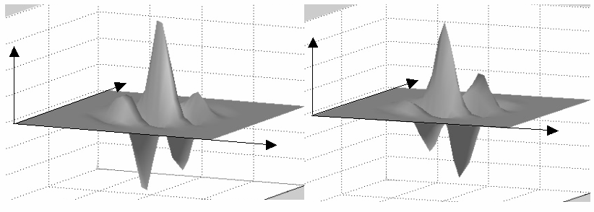

z

z

y

y

x

x

**Figure 4.1 –** A quadrature pair of 2D Gabor filters **left)** real component or even symmetric filter characterised by a cosine modulated by a Gaussian **right)** imaginary component or odd symmetric filter characterised by a sine modulated by a Gaussian.

Daugman demodulates the output of the Gabor filters in order to compress the data. This is done by quantising the phase information into four levels, for each possible quadrant in the complex plane. It has been shown by Oppenheim and Lim [[23]](#_bookmark80) that phase information, rather than amplitude information provides the most significant information within an image. Taking only the phase will allow encoding of discriminating information in the iris, while discarding redundant information such as illumination, which is represented by the amplitude component.

These four levels are represented using two bits of data, so each pixel in the normalised iris pattern corresponds to two bits of data in the iris template. A total of 2,048 bits are calculated for the template, and an equal number of masking bits are generated in order to mask out corrupted regions within the iris. This creates a compact 256-byte template, which allows for efficient storage and comparison of irises. The Daugman system makes use of polar coordinates for normalisation, therefore in polar form the filters are given as



**4.3.1 Feature Encoding**

We use **Gabor filter banks for texture classification** for determining and storing the features of a certain image. Here the Gabor Kernel is used to classify textures based on Gabor filter banks. Frequency and orientation representations of the Gabor filter are similar to those of the human visual system. The images are filtered using the real parts of various different Gabor filter kernels. The mean and variance of the filtered images are then used as features for classification, which is based on the least squared error for simplicity.

In this method we first create a null matrix as the container for the kernel which is to be created.

The kernel is just the template for extracting the feature from the given image as it scans through the whole image and applies gabor filter kernel which figure outs the characteristics or feature of certain different points in the image.

**4.3.2 Matching**

After we have successfully recorded the unique features of every image and stored them in suitable Data Structure, Its time for us to retrieve information by searching by a certain image file or index which is stored in the Data structure (Multi-dimensional array) and match them with the current image in examination. That is as different template containing different information are stored in the array then we match the image under observation with all the stored templates in the array and check the matching percentage and we announce the image with the highest percentage of matched ratio, as the probable image complementary to the image under observation currently.

Now this method proves to be efficient as we match with all the image templates available and we compare the percentages of the matching ratios and thus we can be fairly assured of that the image is accurately identified , As we can guarantee that even right and left eye images of a single person would give huge differences’ in matching percentages ratio thus it nearly works as Hamming distance method.

Though we do not directly implement the Hamming distance method, still we reach the same milestone of accurately finding the image by only using Gabor filter and applying kernels to retrieve or match the extracted features.

**CONCLUSION**

**T**hus we conclude that we have successfully Applied the Iris recognition method starting from Localization to Feature extraction and matching and successfully identifying a certain individual iris stand out from the rest of others. Thus we again prove that

a)Iris is the safest Biometrics for identification as – even the right and left eyes of a single person would not match convincingly.

b)This uniqueness of every iris and the short amount of time required to decode the information are the main phenomenon for which makes this scalable in every aspect.

We conclude with the statistics that we matched all the Images in the IITD iris database and found a success ratio of around 98% while implementing our methods.

**Future Work**

Every human being has a unique Iris pattern, even the twins possesses different unique Iris patterns, thus we can say it is a dependable means of identifying any animal species. Most interestingly Iris pattern and its uniqueness do not only stop in identifying human being, it has a very widespread application in various sectors of modern-day life. Aviation industry uses Iris pattern recognition for various purposes including security etc.Quite naturally it is one of the most dependable authentication schemes. But Iris tells us more than we think-Iris pattern can be studied to find out potential diseases’ symptoms. Recently Google published their research paper on Diabetes detection using Iris pattern-In this project our first aim is to successfully execute the human identification but we are eyeing a bigger goal that is detecting medical condition by observing the Iris pattern, that will be a breakthrough if we can achieve this.

**BIBLIOGRAPHY**

[1] Richard Hamming, “Error detecting and error correcting codes”, The Bell System Technical Journal, Volume 29, No. (2), pp 147-160, April 1950.

[2] Theo Pavlidis, “Algorithms for Graphics and Image Processing”, Computer Science Press, Rockville, Maryland, Volume 17, pp 416-432, 1982.

[3] *M.* Kass, A. Witkin, D. Terzopoul, "Snakes: Active contour models", International Journal of Computer Vision. 1, Volume 4, pp 213-231, 1988.

[4] D. Gabor, “Theory of Communication”, J. Inst. Electr. Eng., Volume 93, pp 429-457, 1946.

[5] L. Cohen, “Generalized phase-space distribution functions”, J. Math. Phys., Volume 7, pp 781-786, 1966.

[6] J. Morlet, G. Arens, E. Fourgeau, and D. Girard, “Wave propagation and sampling theory”, Geophysics, Volume 47, pp 203-236, 1982.

[7] H. Nyquist, “Certain factors affecting telegraph speed”, Bell Systems Technical Journal, Volume 3, pp 324-341, 1924.

[8] M. Bovik, A.C. Clark and W.S. Geisler, “Multichannel texture analysis using localized spatial filters”, Intelligence, Volume: 12, Issue: 1, pp 273-294, Jan 1990.

[9] F. Heitger, L. Rosenthaler, R. Heydt, E. Peterhans, and O. Kubler, “Simulation of neural contour mechanisms: from simple to end-stopped cells”, Vision Research, Volume 5, No. (5), pp 963-981,1992.

[10] L. Rosenthaler, F. Heitger, O. Kübler, and R. von der Heydt, “Detection of general edges and key points”, In European Conference on Computer Vision, Volume 24, pp 78-86, 1992.

[11] J.V.B. Soares, J.J.G. Leandro, R.M.C. Jr, H.F. Jelinek, and M.J. Cree, “Retinal vessel segmentation using the 2-D Gabor wavelet and supervised classification”, IEEE Trans. on Medical Imaging, Volume 25, No. (9), pp 1214-1222, 2006.

[12] M. Pötzsch, N. Krüger, and C. Malsburg, “Improving object recognition by transforming Gabor filter responses”, Network: Computation in Neural Systems, Volume 7, No. (2), pp 341-347, 1996.

[13] J. Daugman, “Complete discrete 2-D Gabor transforms by neural networks for image analysis and compression”, IEEE Trans. Acoust. Speech Signal Proc., Volume 36, No. (7), pp 1169-1179, 1988.

[14] D.J. Heege, “Model for extraction of image flow”, J. Opt. Soc. Amer. A, Volume 4, No. (8), pp 1455-1471, 1987. 60

[15] J.G. Daugman, “High confidence visual recognition of persons by a test of statistical independence”, IEEE Transactions on Pattern Analysis and Machine Intelligence, Volume 15, pp 1148-1155, Nov 1993